# **Assignment**

**1) What is SDLC?**

A. SDLC stands for Software Development Life Cycle. SDLC structure imposed on the development of software product that defines the process for planning, implementation, testing, documentation, deployment, ongoing maintenance and support.

**2) What is Software Testing?**

A. Software Testing is a process used to identify the correctness, completeness and quality of developed computer software.

**3) What is Agile methodology?**

A. The Agile methodology is a project management approach that involves breaking the project into phases and emphasizes continuous collaboration and improvement. Teams follow a cycle of planning, executing and evaluating.

**4) What is SRS?**

A. A software requirements specification is a complete description of the behavior of the developed system.

**5) What is OOPS?**

A. A Object Oriented Programming System is a powerful programming paradigm that views software as a collection of objects that interact by sending message to each other.

**6) Write Basic Concepts of OOPS.**

A. There are seven basic concepts

1. Object
2. Class
3. Encapsulation
4. Inheritance
5. Polymorphism
6. Abstraction

**7) What is an Object?**

A. Object is a basic unit of oops. That is both data and function that operate on data are bundled as a unit called as object.

**8) What is Class?**

A. In oops class is a blueprint for creating objects. It defines the state and behavior of the object that are created from it.

**9) What is Encapsulation?**

A. Encapsulation is the practice including in an object everything it needs hidden from other objects. The internal state is usually not accessible by other objects.

**10) What is Inheritance?**

A. Inheritance is powerful tool in oops. Inheritance means that one class inherits characteristics of another class. This is also called “is a” relationship.

**11) What is Polymorphism?**

A. Polymorphism is a powerful feature of oops it allows different objects to respond to the same message in different ways, the response specific to the type of the object.

**12) Draw Use case on online book shopping.**

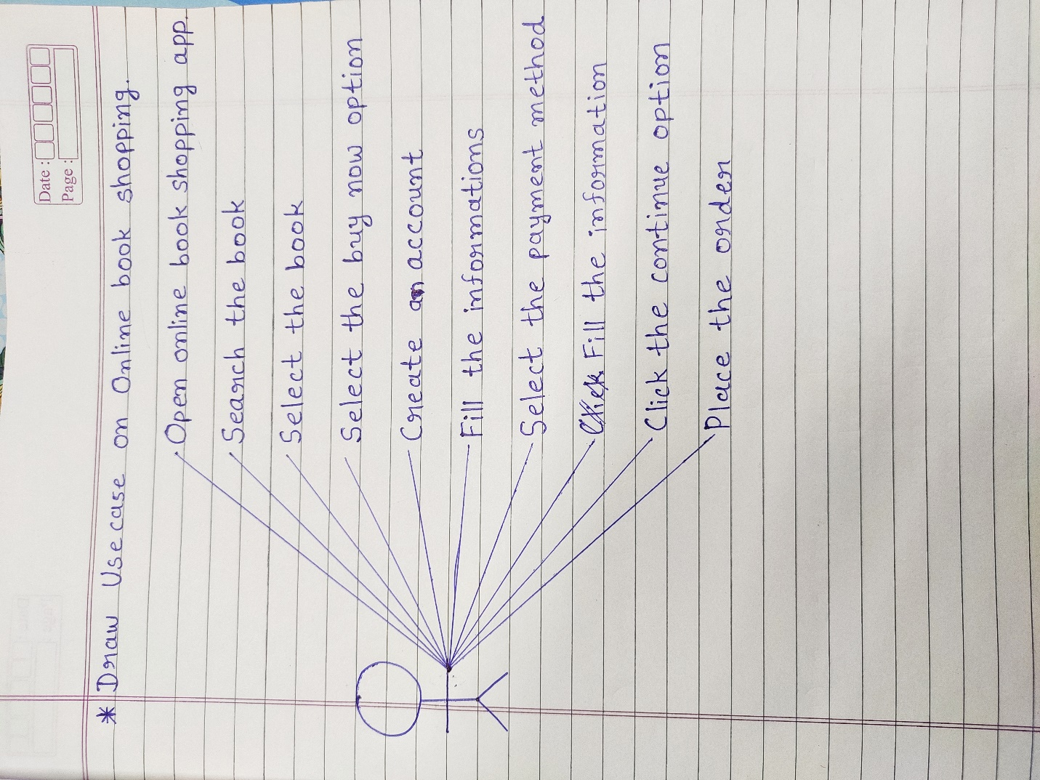

**13) Draw Use case on online bill payment system (paytm).**

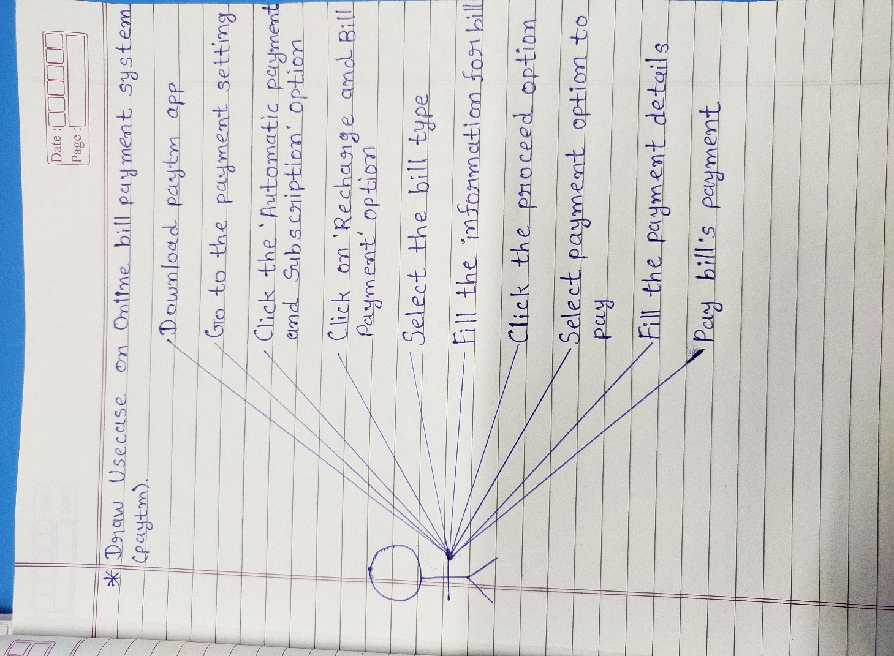

**14) Write SDLC phases with basic introduction.**

A. 1. Requirements gathering - Establish customer needs

~ The process of identifying, collecting and documenting the

requirements for a new software system.

Types of Requirements:-

Functional Requirements: Describe system services or functions.

Non-functional Requirements: This requirements are constraints

on the system or the development

process.

2. Analysis - Model and specify the requirements “What”

~ The analysis phase defines the requirements of the system,

independent of how these requirements will be accomplished.

3. Design - Model and specify a solution “Why”

~ It ensure that the product is well-designed and meets the needs of

the users.

4. Implementation - Construct a solution in software

~ The implementation phase, the team builds the components either

from scratch or by composition.

5. Testing - Validate the solution against the requirements

~ Testing phase is a separate phase which is performed by a

different team after the implementation is completed.

6.Maintenance - Repair defects and adapt the solution to the new

requirements

~ Maintenance is the process of changing a system after it has been

deployed.

Types of Maintenance:-

Corrective maintenance: Identifying and repairing defects

Adaptive maintenance: Adapting the exiting solution to the new

platforms.

Perfective maintenance: Implementing the new requirements

**15) Explain phases of the waterfall model.**

A. The classical software lifecycle models the software development as a step-by-step “waterfall” between the various development phases.

The six phases of the waterfall model are requirements collection, analysis, design, implementation, testing and maintenance.

**16) Write phases of spiral model.**

A. The four phases of spiral model are:-

Planning - Determination of objectives, alternatives and constraints.

Risk Analysis - Analysis of alternatives and identification/resolution

of risks.

Engineering - Development of the “next level” product.

Customer Evolution - Assessment of the results of engineering.

**17) Write Agile manifesto principles.**

A. There are four agile manifesto principles:

1. Individual Interaction

2. Working Software

3. Customer Collaboration

4. Responding to Change

**18) Explain working methodology of agile model and also write pros and cons.**

A. Agile SDLC model is a combination of iterative and incremental models with focus on process adaptability and customer satisfaction by rapid delivery of working software product.

* Agile method break the product into small incremental builds. These builds are provided in iterations. Each iteration typically lasts from about one to three weeks.
* Every iteration involves cross functional teams working simultaneously on various areas like planning, requirement analysis, design, coding, unit testing and acceptance testing.
* At the end of the iteration a working product is displayed to the customer and important stakeholders.

**Pros:-**

* Is very realistic approach to software development
* Promotes teamwork and cross training.
* Functionality can be developed rapidly and demonstrated.
* Easy to manage
* Gives flexibility to developers
* Resource requirements are minimum.
* Suitable for fixed or changing requirements
* Delivers early partial working solutions.

**Cons:-**

* Not suitable for handling complex dependencies.
* More risk of maintainability, sustainability and extensibility.
* Depends heavily on customer, if customer is not clear, team can be driven in the wrong direction.
* Transfer of new technology to new team members may be quite challenging due to lack of documentation.
* There is very high individual dependency, since there is minimum documentation generated.

**19) Draw Use case on online shopping product using COD.**

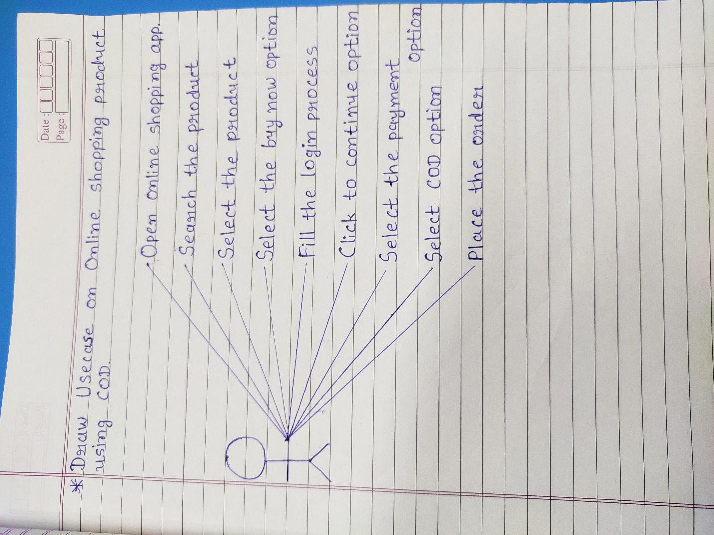

**20) Draw Use case on online shopping product using payment gateway.**

